St. Luke’s Marking and Feedback Policy

This policy should be read in conjunction with the school’s Teaching and Learning Policy.
Policy was initially agreed with staff and governors: September 2016 and has been recently reviewed in March 2023

To be reviewed: Annually

‘Assessment for Learning is the process of seeking and interpreting evidence for use by learners and their teachers to decide where the learners are in their learning, where they need to go next, and how best to get them there.’
The Assessment Reform Group, 2002
Purpose
- To celebrate learner’s success and identify the next steps in learning.
- To continually inform and develop teacher’s planning and teaching, tailored to the needs of the class, group, or learner.
- To develop children’s ability to evaluate their own and peer success, and identify the next steps in learning.
- To annotate for formal assessment and levelling.
- To identify whether learning is being committed to long-term memory.

Principles
- Feedback should be completed by lead facilitators (teachers, teaching assistants, learning mentor, supply teachers, nursery nurses), using green ink as soon as possible after the work has been completed. This may also be within the lesson.
- We seek to develop self and peer feedback to raise self-esteem and develop independence. This may include:
- Sharing peer examples of work;
- Teacher modelling feedback;
- Peer feedback or friendly feedback to be established through a class ethos that is respectful, constructive and
responsive to learner’s needs

- Verbal feedback is an essential part of recognising success and raising a learner’s self-esteem. Where possible learners may be given the opportunity to record their understanding of the verbal feedback given. We indicate verbal back using the initials ‘vf’ as per the school’s marking codes.
- All work should be acknowledged with more detailed diagnostic marking left to the professional discretion of the class teacher, based on the nature of the task. More detailed diagnostic marking would be required for tasks such as longer writing pieces, scientific investigations, or problem-solving investigations in maths . For example, a fact finding task may not require detailed feedback, whereas a longer written piece would.
- Where applicable, personalised next steps should be given to move the children on in their learning. These comments should be bespoke and directly related to the task. For example, if a child is continually missing out capital letters, your next step could be based around this. Next steps are not the same as a “challenge” question, which is not an expectation of the marking and feedback policy but something teachers might do in order to support children who finish work early or wish to extend their learning further.
- There is an expectation that all marking and feedback is consistently up to date. Falling behind on marking and feedback means that assessment is not informing learning. It renders later marking and feedback a burden to the teacher and marking and feedback given at a later date is generally unhelpful to the child’s progress in learning. If you do find that you need support with marking, you should make your line manager aware so that support can be given with this.
- Time must be given for learners to respond to the feedback given through implementing the next steps in their learning. This will be clearly done in red pen. Please note that we do not expect this dialogue to extend beyond one set feedback.

Approach taken
All pieces of work have a Learning Objective as a WALT (We are learning to), and all pieces of work in the core subjects will have success criteria.
Basic level marking:
For this the ‘marker’ will highlight evidence in the child’s work that the success criteria have been met in pink. They will highlight where the work could have been improved in green. They will then highlight the success criteria as relevant to its achievement.
We have a list of agreed marking codes. These may be used as relevant and should be on display in all classrooms as a reference point as well as available for the children on their tables.
Diagnostic marking:
When a child is receiving more detailed feedback, the feedback will reflect what the child has done well against the success criteria and what their next step should be. It will be clear that the feedback is supported by highlighted evidence in the child’s work i.e. if lots of adjectives are highlighted in pink, the use of adjectives will have been in the success criteria and the marker will comment on how well the child has used adjectives.
Continuing the last example, if some adjectives have been highlighted in green, then the comment might be encouraging more creative adjectives or offering some alternatives to choose from that would have a greater impact.
If the child has struggled with their work, then it is likely further explanation will be modelled before asking them to try an aspect again. If they have done well with the work it is likely they may then be asked to apply what they have done to a different context or to explain their reasoning in greater detail thereby deepening or extending their understanding.
When giving children feedback and next steps, if we ask them to do something ‘next time’ we ensure that we follow up on this. Ideally we want them to do something now so that the impact of our marking on their learning is clear. There will be clear evidence in their books of marking that moves forward their learning and understanding over time. Children will cease repeating the same mistakes as evidence of teacher impact.
Examples of prompts are given in the Appendix.
Spelling:
Spelling mistakes do not have to be identified in every piece of writing however we need to be mindful of their spelling success and consistent misspelling of an ‘ability level appropriate’ spelling should not go unchallenged. This is a classic example of where we need to be able to demonstrate the positive impact of feedback given.
Foundation Stage spelling mistakes are generally not corrected, and children are always praised and encouraged for attempting to spell the high frequency words and ‘having a go’.
Early Years Adult Input:
In Early Years, child voice needs to be recorded for each pieces of work that goes into WOW books, along with a reference to the areas of learning that are relevant to that piece of work
On occasion, when there is a substantial piece of work, ensure there is a next step to move the child on in their learning (for example, if a child is learning to count and sequence numbers, a next step could be subitising).
Child observations during child-initiated free-play should be recorded regularly to document any significant moments that arise.
Leadership and Development:
Marking is monitored through book looks by the senior leadership team and subject leaders. These may be planned in the monitoring and evaluation schedule, alongside regular ‘learning check ins’ so that subject leaders have a clear understanding of the impact and implementation of their subject throughout the school.
Appendix
Examples of Next-Step Marking from Across the School:
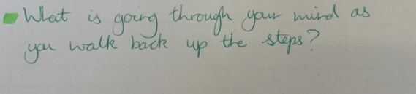  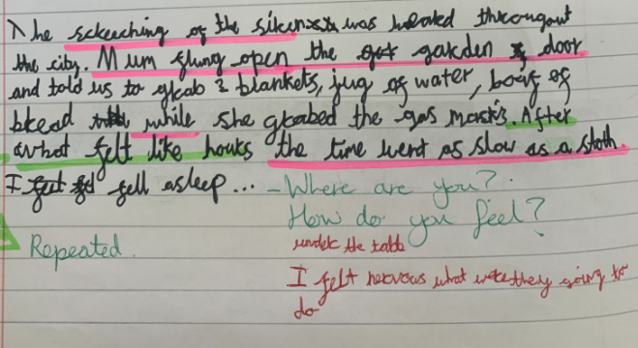 | - Question prompts to support child with developing their writing
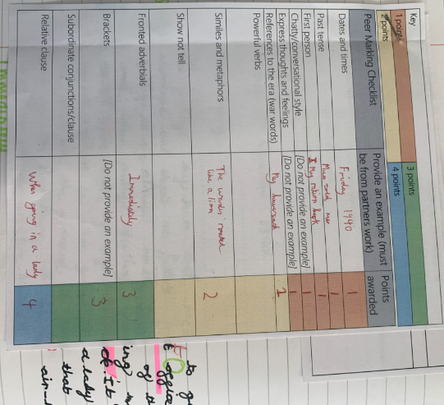 | Peer editing checklist
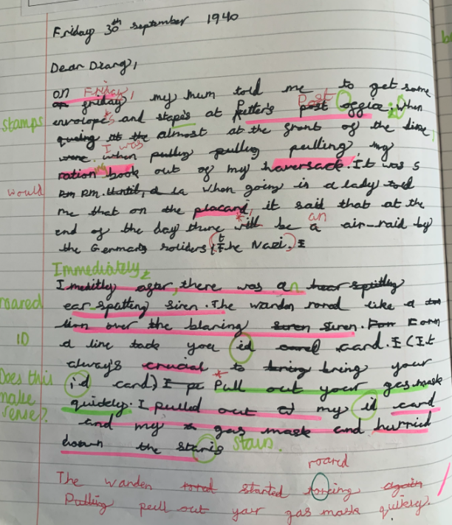 | - Incorrect spellings identified  - Child has responded in red pen  - “Does this make sense”; pupil has read over work and made amendments in red below
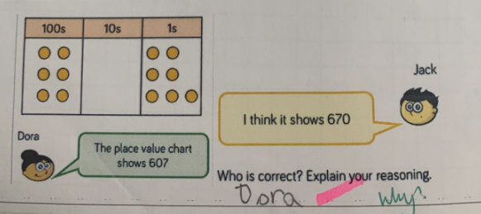 | - Challenging child to explain their logic
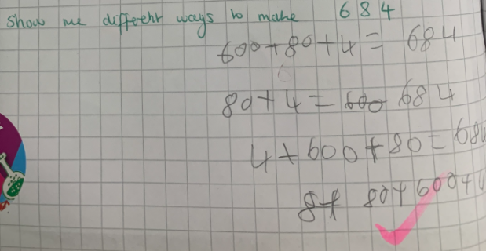 | - Children being challenged to apply learning with a larger number
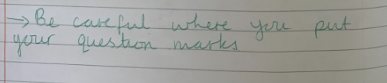  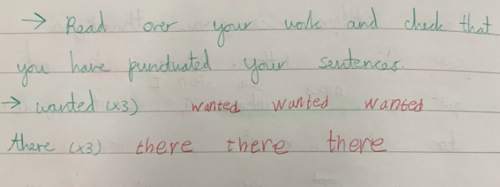 | - Area of difficultly identified by teacher
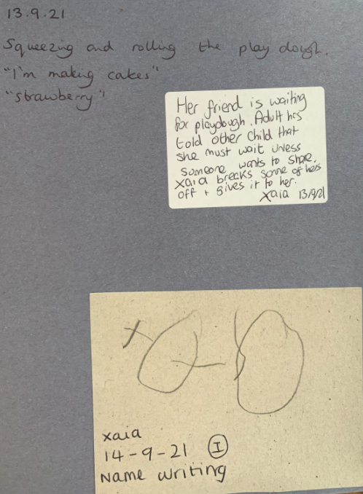 | - Examples of observations in a child’s WOW book
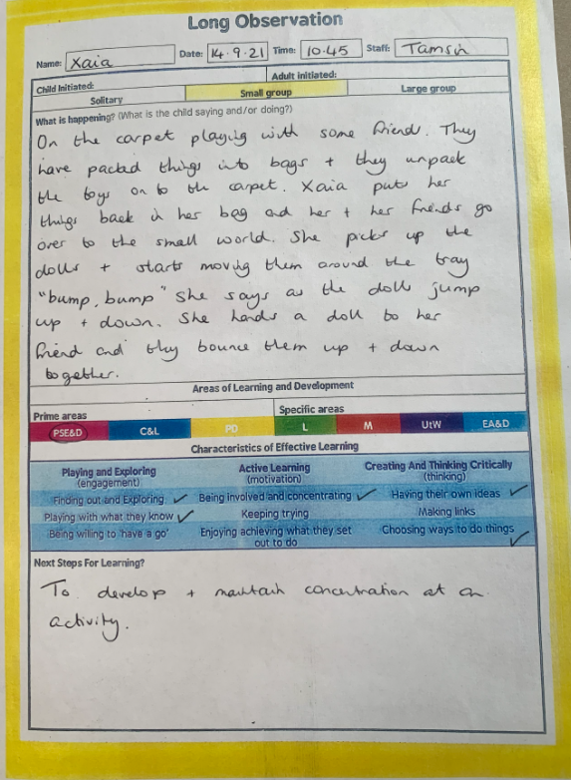 | - Long observation in a child’s WOW book
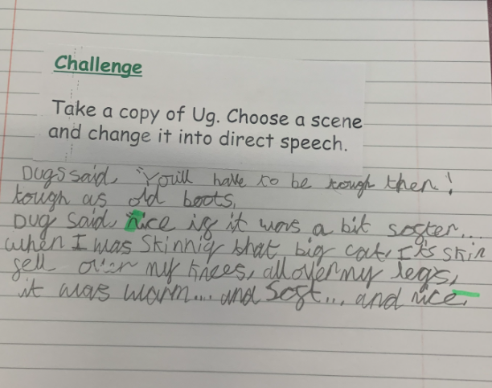 | - Example of a challenge; pre-printed question based on lesson not individual child’s work

Useful Prompts to Support Next Steps:
These are examples in different areas taken from “Enriching Feedback in the Primary Classroom”, by Shirley Clarke, published by Hodder & Stoughton 2003.
RANGE OF PROMPTS | LEARNING INTENTION | EXTRACT FROM CHILD’S WRITING | REMINDER PROMPT | SCAFFOLD PROMPT | EXAMPLE PROMPT
Why?  (justifying a statement) | To write a letter giving reasons for things you say | “it was dismal” | Say why you thought this. | Why was this a dismal time? Why did you hate being there? | Choose one of these or your own:  - It was dismal because I was bored all the time  - I found it dismal having only my granddad to talk to.
How did you/she feel? | To retell story showing people’s feeling | “Nobody believed him” | Say how you think this made him feel. | How do you think he felt? Do you think he might have regretted anything he’d done before | How do you think he felt?  - Angry that people did not trust him.  - Annoyed with himself for lying in the past.
Add something | To use effective adjectives and adverbs in an account | “Jason was trying to distract him, but the dragon was too strong” | Use more adverbs and adjectives here. | Jason tried.... to distract him, but the dragon ........ly used his strength to get past, Jason stabbed his sword ....ly into the dragon’s nearest side | Choose one or use your own:  - The dragon’s tail lashed viciously, cutting Jason’s flesh...
Change something | To use effective adjectives in a description | “He was a bad monster” | Think of a better word than bad | What kind of monster was he? Change bad for something that makes him look more scary. | Try one of these or use your own:  - Ferocious  - Terrifying  - evil
Tell us more | To introduce a character in a story opening | “James went to school” | Could you describe James? | What type of boy was he? Good kind, shy, excitable, loud? Help us to know him | Describe James’s character. Perhaps:  - James was a kind, likeable boy with a great sense of humour
What happens next? | To write a middle and end from a given start | “At last the merman saw the mermaid.” | How is your story going to end | What do you think the merman said to the mermaid before they went home together? | Write one of these or your own ending:  “i love you” said the merman. The mermaid took his hand and they swam away

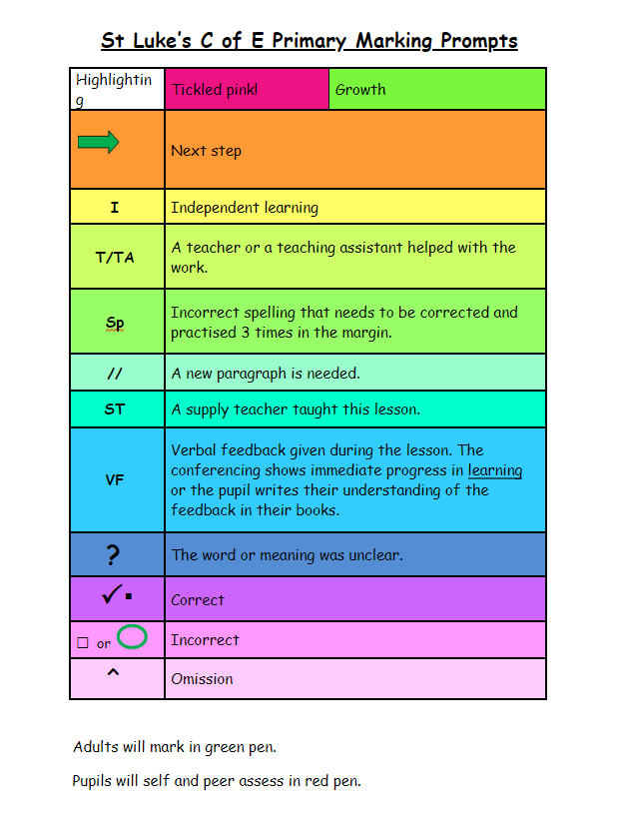

For teachers

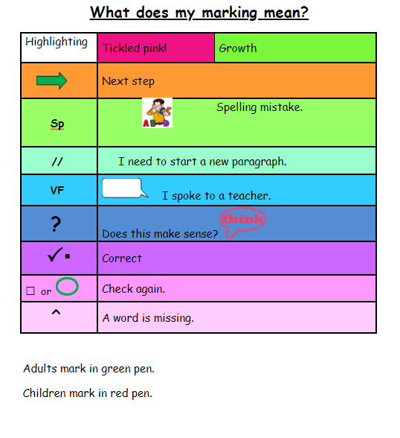
For pupils

