First Aid Policy

St Luke’s Primary School

Approved by: | Governing Board | Date: May 2021
Next review date: | May 2024

Contents
1. Aims 2
2. Legislation and guidance 2
3. Roles and responsibilities 3
4. First aid procedures 4
5. First aid equipment 5
6. Record-keeping and reporting 5
7. Training 7
8. Monitoring arrangements 7
9. Links with other policies 7
Appendix 1: Accident/Incident/Illness report form 8
Appendix 2: Guidance on infection control in schools and other childcare settings 9

………………………………………………………………………………………………………………………

Aims
The aims of our first aid policy are to:
- Ensure the health and safety of all staff, pupils and visitors
- Ensure that staff and governors are aware of their responsibilities with regards to health and safety
- Provide a framework for responding to an incident and recording and reporting the outcomes

Legislation and guidance

This policy is based on the Statutory Framework for the Early Years Foundation Stage, advice from the Department for Education on first aid in schools and health and safety in schools, and the following legislation::
- The Health and Safety (First Aid) Regulations 1981, which state that employers must provide adequate and appropriate equipment and facilities to enable first aid to be administered to employees, and qualified first aid personnel
- The Management of Health and Safety at Work Regulations 1992, which require employers to make an assessment of the risks to the health and safety of their employees
- The Management of Health and Safety at Work Regulations 1999, which require employers to carry out risk assessments, make arrangements to implement necessary measures, and arrange for appropriate information and training
- The Reporting of Injuries, Diseases and Dangerous Occurrences Regulations (RIDDOR) 2013, which state that some accidents must be reported to the Health and Safety Executive (HSE), and set out the timeframe for this and how long records of such accidents must be kept
- Social Security (Claims and Payments) Regulations 1979, which set out rules on the retention of accident records
- The School Premises (England) Regulations 2012, which require that suitable space is provided to cater for the medical and therapy needs of pupils

Roles and responsibilities

3.1 Appointed person(s) and first aiders
The school’s appointed Lead First Aider are responsible for:
- Taking charge when someone is injured or becomes ill
- Ensuring there is an adequate supply of medical materials in first aid kits, and replenishing the contents of these kits
- Ensuring that an ambulance or other professional medical help is summoned when appropriate
First aiders are trained and qualified to carry out the role (see section 7) and are responsible for:
- Acting as first responders to any incidents; they will assess the situation where there is an injured or ill person, and provide immediate and appropriate treatment
- Sending pupils home to recover, where necessary
- Filling in an accident report on the same day, or as soon as is reasonably practicable, after an incident (see the template in appendix 2) ensuring that what’s recorded is accurate, clear and written in plain English.
- Keeping their contact details up to date
A detailed list of first aiders is kept in the school office. The names of our first aiders and their location are displayed prominently around the school.

3.2 The governing board
The governing board has ultimate responsibility for health and safety matters in the school, but delegates operational matters and day-to-day tasks to the Executive Headteacher and staff members.

3.3 The Executive Headteacher
The Executive Headteacher is responsible for the implementation of this policy, including:
- Ensuring that an appropriate number of trained first aid personnel are present in the school at all times
- Ensuring that first aiders have an appropriate qualification, keep training up to date and remain competent to perform their role
- Ensuring all staff are aware of first aid procedures
- Ensuring appropriate risk assessments are completed and appropriate measures are put in place
- Ensuring that adequate space is available for catering to the medical needs of pupils
- Reporting specified incidents to the HSE when necessary (see section 6)

3.4 Staff
School staff are responsible for:
- Ensuring they follow first aid procedures
- Ensuring they know who the first aiders in school are
- Completing accident reports (see appendix 1) for all incidents they attend to where a first aider is not called
- Informing the Executive Headteacher, Lead First Aider or a member of the SLT of any specific health conditions or first aid needs

First aid procedures

4.1 In-school procedures
In the event of an accident resulting in injury:
- The closest member of staff present will assess the seriousness of the injury and seek the assistance of a qualified first aider, if appropriate, who will provide the required first aid treatment
- The first aider, if called, will assess the injury and decide if further assistance is needed from a colleague or the Lead First Aider. The Lead First Aider, or a member of the SLT in her/his absence will decide if assistance needs to be sought from the emergency services. All involved will remain on scene until help arrives
- The first aider will also decide whether the injured person should be moved or placed in a recovery position
- If the Lead First Aider or member of the SLT judges that a pupil is too unwell to remain in school, parents will be contacted by a first aider and asked to collect their child. Upon their arrival, a first aider will recommend next steps to the parents
- If emergency services are called, the Lead First Aider or a member of SLT will ensure a member of staff contacts parents immediately
- The first aider that has dealt with the injury will complete an accident report form on the same day or as soon as is reasonably practical after an incident resulting in an injury ensuring that what’s recorded is accurate, clear and written in plain English.
- In the event of a child incurring a head or a more serious bump or graze, the first aider on duty will contact parents to inform them of the accident and to determine whether the parent is happy for their child to continue in school or not.
- For midday supervision there is a senior first aider who is responsible for overseeing all lunchtime first aid

4.2 Off-site procedures
When taking pupils off the school premises, staff will ensure they always have the following:
- At least one mobile phone
- A portable first aid kit
- Information about the specific medical needs of pupils
- Access to contact details
Risk assessments will be completed by the trip organiser prior to any educational visit that necessitates taking pupils off school premises. These risk assessments are authorised either by the Executive Headteacher or the Head of School.
There will always be at least one first aider with a current pediatric first aid certificate on school trips and visits, as required by the statutory framework for the Early Years Foundation Stage.

First aid equipment
A typical first aid kit in our school will include the following:
- A leaflet with general first aid advice
- Regular and large bandages
- Eye pad bandages
- Triangular bandages
- Adhesive tape
- Disposable gloves
- Antiseptic wipes
- Plasters (hypoallergenic) of assorted sizes
- Cold compresses
- Burns dressings
- Sterile Eye Wash
- Mouth Guard
- Foil Blanket
- Incident Book

No medication is kept in first aid kits.

First aid kits are stored in:
- The Medical Room
- School Office
- All classrooms
- The School Kitchen
- Swimming Pool
- School Grounds
- Community House

Defibrillator
The school has purchased a defibrillator which is located in the School Office.

Record-keeping and reporting
6.1 First aid and accident record book
- An accident form will be completed by the first aider on the same day or as soon as possible after an incident resulting in an injury
- As much detail as possible should be supplied when reporting an accident, including all of the information included in the accident/incident/illness form at appendix 1. What’s recorded needs to be accurate, clear and written in plain English.
- The first aider will arrange for a copy of this form to be given to the parents
- Our insurers require that records held in the first aid and accident book are kept for 3 years and 3 months after the accident, before being securely disposed of, because that is the time allowed for an injured person to instruct a solicitor to serve legal proceedings. In the case of a child such records will need to be kept until they are age 21 and 3 months because this time period commences from the date that the child reaches the age of majority

6.2 Reporting to the HSE
The Executive Headteacher will ensure that a record is kept of any accident which results in a reportable injury, disease, or dangerous occurrence as defined in the RIDDOR 2013 legislation (regulations 4, 5, 6 and 7).
The Executive Headteacher will ensure that these are reported to the Health and Safety Executive as soon as is reasonably practicable and in any event within 10 days of the incident.
Reportable injuries, diseases or dangerous occurrences include:
- Death
- Specified injuries, which are:
  - Fractures, other than to fingers, thumbs and toes
  - Amputations
  - Any injury likely to lead to permanent loss of sight or reduction in sight
  - Any crush injury to the head or torso causing damage to the brain or internal organs
  - Serious burns (including scalding)
  - Any scalping requiring hospital treatment
  - Any loss of consciousness caused by head injury or asphyxia
  - Any other injury arising from working in an enclosed space which leads to hypothermia or heat-induced illness, or requires resuscitation or admittance to hospital for more than 24 hours
- Injuries where an employee is away from work or unable to perform their normal work duties for more than 7 consecutive days (not including the day of the incident)
- Where an accident leads to someone being taken to hospital
- Near-miss events that do not result in an injury, but could have done. Examples of near-miss events relevant to schools include, but are not limited to:
  - The collapse or failure of load-bearing parts of lifts and lifting equipment
  - The accidental release of a biological agent likely to cause severe human illness
  - The accidental release or escape of any substance that may cause a serious injury or damage to health
  - An electrical short circuit or overload causing a fire or explosion
Information on how to make a RIDDOR report is available here:
How to make a RIDDOR report, HSE
http://www.hse.gov.uk/riddor/report.htm

6.3 Notifying parents
An appropriate member of staff will inform parents of any accident or injury sustained by a pupil, and any first aid treatment given, on the same day, or as soon as reasonably practicable.

6.4 Reporting to Ofsted and child protection agencies
The Executive Headteacher will ensure that Ofsted is notified of any serious accident, illness or injury to, or death of, a pupil while in the school’s care. This will happen as soon as is reasonably practicable, and no later than 14 days after the incident.
The Executive Headteacher will also ensure that the Multi Agency Safeguarding Hub is notified via the Child Protection Advice Line on 020 7364 5006 (option 3) of any serious accident or injury to, or the death of, a pupil while in the school’s care.

Training
All school staff are able to undertake first aid training if they would like to, subject to course availability and budget.
All first aiders must have completed a training course, and must hold a valid certificate of competence to show this. The school will keep a register of all trained first aiders, what training they have received and when this is valid until.
Staff are encouraged to renew their first aid training when it is no longer valid.
At all times, at least 1 staff member will have a current pediatric first aid (PFA) certificate which meets the requirements set out in the Early Years Foundation Stage statutory framework and is updated at least every 3 years.

Monitoring arrangements
This policy will be reviewed by the Lead First Aider & Business Manager every three years. At every review, the policy will be approved by the Executive Headteacher & Governing Board.

Links with other policies
This policy links to the following policies:
- Accessibility Policy
- Complaints Procedure
- Equality information and objectives
- Health and Safety Policy
- Intimate Care Policy
- Risk Assessment Policy
- Safeguarding
- SEN and Inclusion Policy
- Supporting Pupils with Medical Conditions Policy

10. Guidance on Infection Control
Posters produced by the Health Protection Agency on Guidance on Infection Control in Schools & Childcare Settings are sited throughout the school.
A copy is attached in Appendix 2.

Appendix 1: Accident/Incident/Illness report form

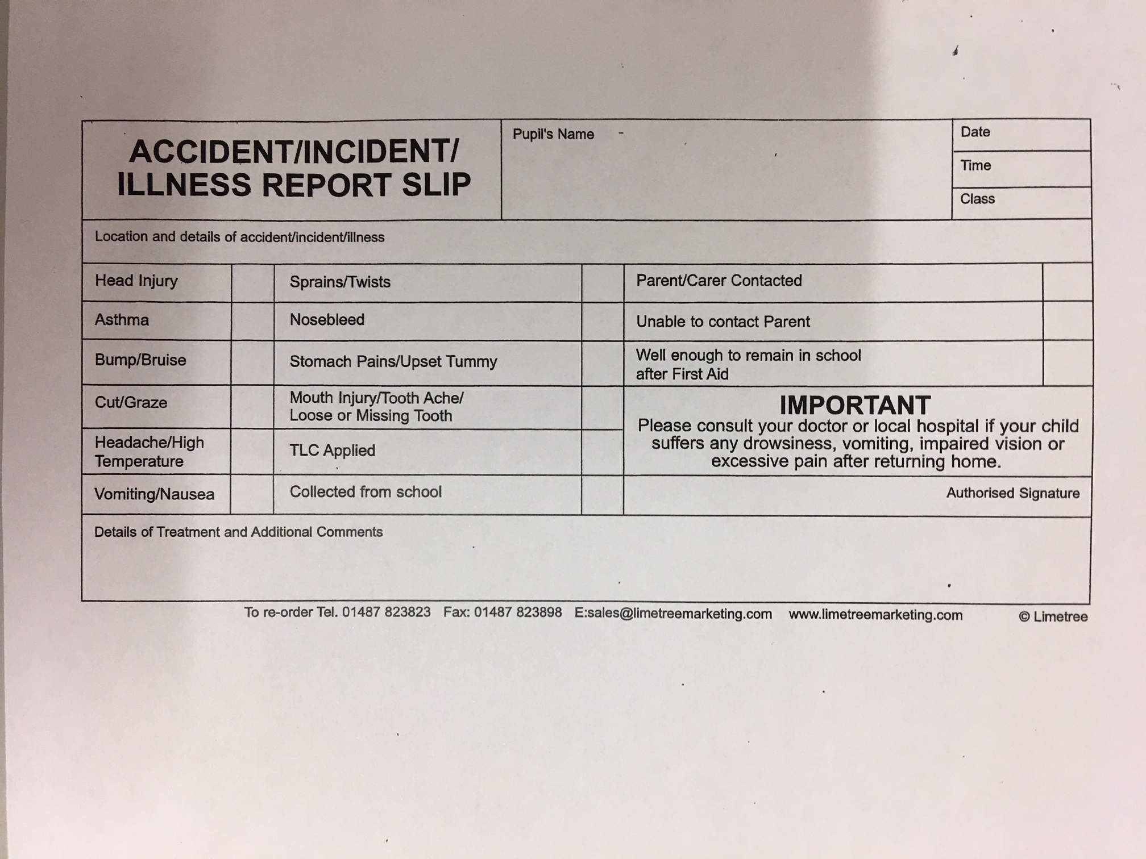

Appendix 2: Guidance on infection control in schools and other childcare settings

