Music Development Plan
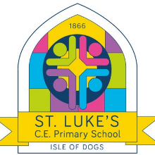
School: St Luke’s Church of England Primary School
Trust/local authority: Tower Hamlets
Local music hub: THAMES
Music lead: Mr. Richard Griffiths
Music specialist (if applicable):
Executive Headteacher: Ms. Alex Allan
Date written: 12.06.23
Review date: 12.06.24
 | Music Development Plan
1 – Overall objective | The overall objective for music provision in your school.  At St. Luke’s, we are standing up for the truth of Christ and love of God. As a diverse community, we have values that are understood and accessible to people of all beliefs and world views.  At St. Luke’s we aim to provide every child with access to a high-quality music curriculum, which will provide them with a solid foundation in musical skills and build every child’s love of the subject through high-quality musical experiences. We seek to provide all children with the opportunity to learn to play a variety of contrasting musical instruments during their time here in the hope that they will develop an affinity with at least one of them and feel motivated to develop their playing further. Furthermore, we feel it is essential that all children learning an instrument also learn to perform that instrument and as such provide a wealth of concert opportunities throughout each year.
2 – Key components | Music in the curriculum  Development Matters to inform our music planning in early years.  We use music express to deliver music in class sessions across Key Stage 1 and Key Stage 2. The sessions are mapped out in Music Express from children’s starting points as they enter Year 1 to allow for progression up to Year 6 through assessing against half term end points for each unit of work.  Singing takes place in classes throughout the curriculum.  3 hymns are sung on Monday’s during our weekly mass, and these are rehearsed in key stages during Wednesday’s singing collective worship.  Hymns are also used during Friday’s celebration assembly where children also evaluate music as they come into collective worship on a Friday.  Each class performs a class assembly each year, alongside a nativity performance and both of these will include elements of singing and dance.  A live professional performance takes place for the children each year as part of our learning guarantees in our wider curriculum document.  In 2022/2023 this was  Nursery – Bach to Baby  Year 1 – 3 – ‘Evergreen’ Interactive Folk Performance  Year 4 – 6 – ‘Wish Gatherer’ London Touring Opera  Music Partnership with THAMES  We work with THAMES to deliver music lessons throughout Year 1 – 4 and provide an opportunity for children to continue an instrument in Year 5 and 6 through an after-school club. We also run a choir for children in Year 5-6.  Children in Year 1 and 2 learn rhythm through playing the drums  Children in Year 3 learn melody through playing the recorder  Children in Year 4 learn violin or cello  Children in Year 5/6 strings continuers and choir  Each term we hold a music concert for children that wish to perform and throughout the year every child who plays an instrument as part of our partnership with THAMES is able to perform.  Music Partnership with ThreeStonesMedia  Delivered alongside our strings sessions in Year 4 we have established a partnership with Three Stones Media who work with our children to produce a soundtrack to an animated story created by children at Stepney All Saints Sixth Form College  Partnership with PianoFun Club  All children in Year 1 – 6 have the opportunity to access paid 1:1 or 1:2 tuition in piano or guitar through PianofunClub – This also allows 5 children who are pupil premium eligible free piano lessons.
3 – Classroom instrumental teaching | Include details of the school’s offer for each year group. How will students progress? Who will teach this? How will instruments be funded? How will lessons be inclusive? Where to next?  Children in Year 1 – 4 have an additional half an hour of instrumental teaching  Timetable of instrumental music across the school  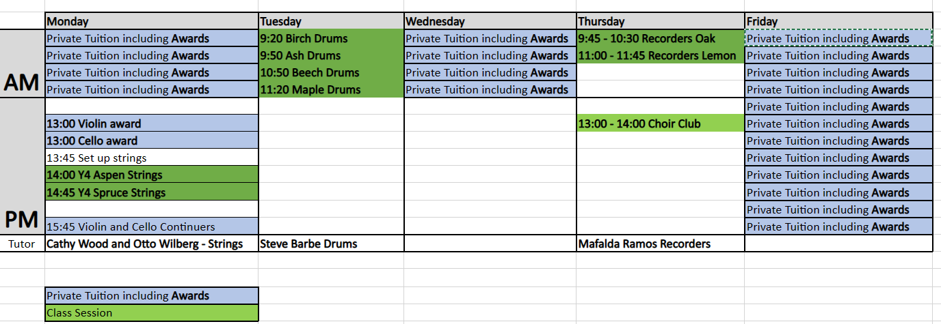  Children’s Concert Performances 2022/2023  Autumn – Nativity Performances  Early Years – 7th December  KS1 – 6th December  KS2 – 13th December  Easter Concert  Monday 20th March (Week 4 Spring 2)  Summer Concert  Monday 3rd July (Week 5 Summer 2)  In Class Private Tuition Sessions  All children in Year 1 – 6 have the opportunity to access paid 1:1 or 1:2 tuition in piano or guitar through PianofunClub – This also allows 5 children who are pupil premium eligible free piano lessons.
4 – Implementation of key components | Music in the curriculum  We use Development Matters to inform our music planning in early years.  We use music express to deliver music in class sessions across Key Stage 1 and Key Stage 2. The sessions are mapped out in Music Express from children’s starting points as they enter Year 1 to allow for progression up to Year 6 through assessing against half term end points for each unit of work.  Teachers deliver 6 Music Express Lessons to their class 30 minutes a week (this can be blocked but is recommended to be taught weekly)  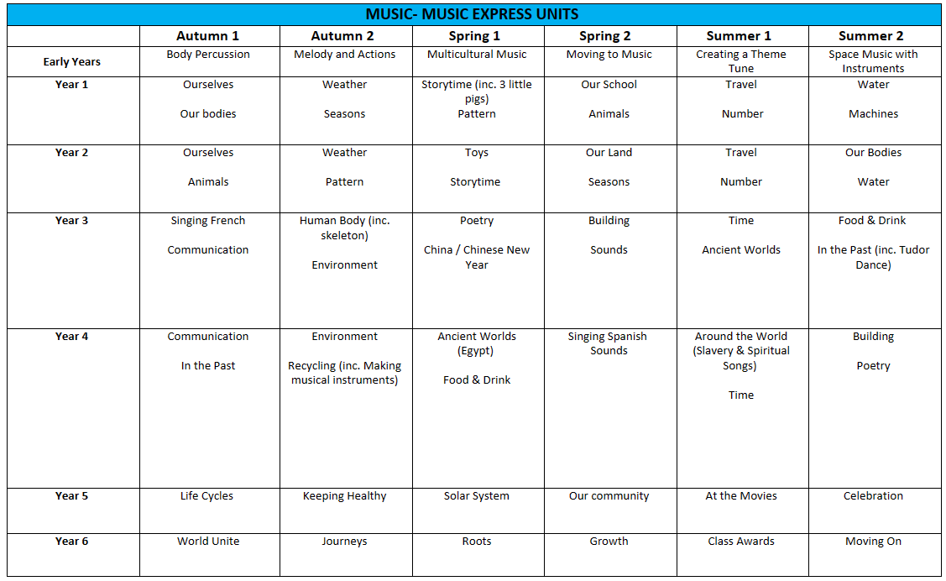  All children have at least 30 minutes of singing a week  Professional Music Performances 2022/2023  Nursery – Bach to Baby  Year 1 – 3 – ‘Evergreen’ Interactive Folk Performance  Year 4 – 6 – ‘Wish Gatherer’ London Touring Opera  Collective Worship and Music  Monday – 3 hymns sang as part of mass  Tuesday – Music used as and when appropriate  Wednesday – 3 hymns rehearsed and reflected upon including musical evaluation  Thursday – Class performance which will include an element of singing and dance  Friday – Music played at start of collective worship which children evaluate and children leave collective worship singing a hymn.  Singing at St Luke’s  The majority of our singing is based around the Come and Praise books with more modern pieces added to the repertoire based on dicussions with Christ Church and our school music lead. We also take guidance from the LDBS collective worship calendar.
5 – Communication activities | We communicate our music opportunities through email with parents including the school newsletter, on the school website and on our school twitter.  Link to website concert news story  Link to music page on school website  Link to school twitter post
6 – Evaluation process for the success of the Music Development Plan | The Music Development Plan will be reviewed and updated annually in the summer term along with our annual meeting with THAMES to discuss provision for the year ahead.  The date of the next review is June 2024
7 – Transition work with local secondary schools | Consider what you will do to maintain musical engagement from Year 6 to Year 7, including any communication you will make with local secondary schools.  In June each year we contact the secondary schools of the children who have been learning and performing an instrument in Year 6.  In 2022/2023 there were 5 more able musicians transitioning from Year 6.
8 – Budget materials and staffing | Cost of Music Express Subscription £276  Provision from THAMES 2022/2023  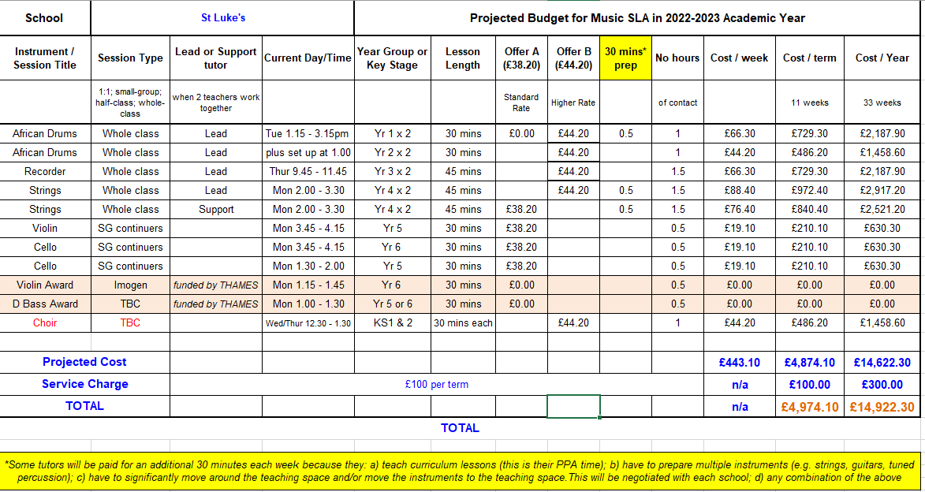
9 – Pupil Premium and SEND provision | THAMES tutors have had specific training on SEND.  Some children use ear defence in their music lessons.  Children are supported to attend teaching assistants.  Instrumental tuition to all children in Year 1 - 4  5 free places for pupil premium children provided through partnership with Piano Fun Club.
10 – Summary Action Plan | Write a list of immediate actions – make them SMART (specific, measurable, achievable, relevant, time-bound).  Action (Intent) Who Implementation Review (impact)  Measure and then target pupil premium student engagement Music Lead THAMES Tutors Ensure 5 pupil premium children are accessing free Piano Fun Club tuition. Register of children attending choir club and Year 5/6 Strings Continuers clubs Look to access the Music Progression Fund (Autumn 2023) to support disadvantaged pupils with significant musical potential, enthusiasm and commitment.  Monitor and support staff engagement with Music Express as a resource. Music Lead All staff teaching music Provide CPD session. Music Observation Walk. Regular access to support Support for new members of staff.  Develop stronger link with feeder secondary schools Music Lead Develop link with secondary music leads. Look for opportunities to work together similar to work this year with ThreeStonesMedia and Stepney All Saints. Is there an opportunity to work towards an ensemble?  Access additional funding from hub/charities/fundraising Music Lead Ensure fundraising is promoted for the school concerts. Stay abreast of developments with THAMES, LGFL and LDBS Look to see if there are any opportunities to apply for greater funding. Music Progression Fund to support disadvantaged pupils with significant musical potential, enthusiasm and commitment.

